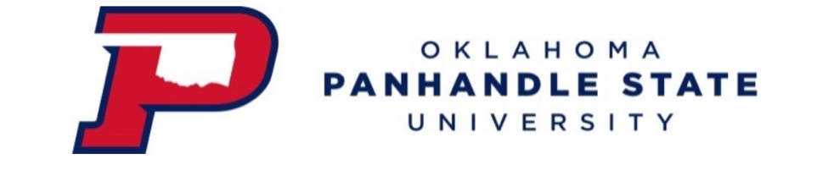
Agenda for Faculty Senate Meeting
Friday, April 14, 2023 12:08 PM SAB 202

Members: | COAE—Shelly Worm, Cheng-Hsien Wu  COASN-- Megan Steele, Abbas Aboohamidi  COBT—Julia Bird, Hue Helms
Present | COAE—Shelly Worm, Cheng-Hsien Wu  COASN-- Abbas Aboohamidi, Megan Steele  COBT—Hue Helms, Kim Smith (in place of Julia)  Amanda Beasley, Amber Hollis-Fresmeir, Stacy Nordquist, Curtis Bensch  Special Guest: Dr. Billiot
Dr. Billiot | Faculty pay study information discussed. Dr. Billiot wants to have faculty pay raises. Wants to be able to look at data. Discussion regarding different professions needing to have different pay scales. Discussions on revenue streams and need to identify different revenues of bringing in money. Looking at hiring deans that have a marketing background to bring in different revenue streams. Enrollment targets and retention rates discussed. EAB partnership funding to be covered by Title V. (Approximately $400,000 per year.) Encouraged faculty to include administration pay in the faculty study. Requests faculty to update pay study and include an action plan. Currently, budget is negative and a large pay increase is not in the budget at this time.  Discussion regarding online classes verse in-person classes. Dr. Billiot wants a vibrant campus to increase retention. Board of Regents are asking questions regarding need for full campus if courses are all online. Students are craving in-person classes. Programs that are online will remain online. Discussion regarding a “one size fits all” regarding hybrid vs online vs in person needs to be different for each college/program. Dr. Billiot states that transformative changes are coming and one change is eliminating hybrid courses. Discussion regarding no current program will be eliminated. Discussion regarding need for advising education so advisors follow the course catalog. Coursedog will be used for scheduling. OSU to be assisting with degree works.  Discussion regarding 1FTE and teaching load. Dr. Billiot will not approve faculty teaching over load. Concern regarding the ability to obtain quality adjunct verse being able to retain faculty.
Meeting called to order at 1314
Reading/Approval of Minutes from 3/10/23 | Abbas motions. Megan seconds. All in favor.
Report from Officers | President- Dr. Cheng Hsien Wu – EAB information discussed. Faculty administrative withdrawal if a student doesn’t come faculty can withdrawal them after 5 weeks.  Vice-President-Dr. Abbas Aboohamidi - Dr. Bates and Dr. Abbas will be submitting HLC Masters of Ag Business degree.  Secretary-Dr. Megan Steele – None
New Business | Discussion for revisions of faculty handbook:  Leave of Absence with Pay Policy: No comments. Megan motions to approve. Hue seconds. All in favor.  Faculty Load: Full-time faculty member should teach a load of 24 hours per contract term. Abbas motions. Megan seconds. All in favor.  Faculty handbook: Amanda Beasley discusses she is updating the grammatical errors and the format of the handbook. Dr. Wu motions, Abbas seconds. All in favor.
Old Business | General education committee and discussion of potential need to drop required hours for bachelor and associate degree plans. State regents are currently still in discussion regarding specific general education requirements.  Faculty Leaving/Turn-off rate is high. See above with Dr. Billiot. Dr. Wu to ask HR for data on leave survey.
Other Business | None.
Announcements | COBT – Clubs went to completion at state and national levels. Students earned awards.  COASN – Have applied for 2 USDA grants.  COAE – An author is coming to visit next Tuesday at 7pm. April 25 at 7pm is music’s Spring Concert.
Adjournment | Next meeting 5/5/23 at 1201pm.  Megan motions to adjourn. Second by Hue. All approved. Adjournment at 1349.

