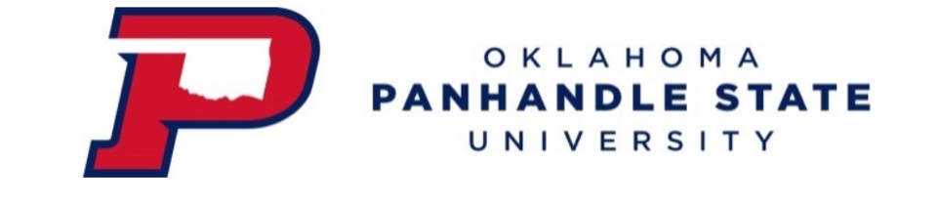
Agenda for Faculty Senate Meeting
Friday, March 10, 2023 12:01 PM SAB 202

Members: | COAE—Shelly Worm, Cheng-Hsien Wu  COASN-- Megan Steele, Abbas Aboohamidi  COBT—Julia Bird, Hue Helms
Present | COAE—Shelly Worm, Cheng-Hsien Wu  COASN-- Abbas Aboohamidi, Megan Steele  COBT—Hue Helms, Julia Bird  Tracy Curtis, Vicky  Special Guests: Mr. Victor Esparza
Mr. Victor Esparza | Spoke with department heads on 2/23/23 with regards to athletic schedule this coming fall and moving on. Difficulty of scheduling due to needing to have students available to eat at the cafeteria or the university has to pay for meals. Difficulty of scheduling required classes based on course schedules, availability of gym and stadium, and cafeteria hours. Discussion regarding when there is a conflict of practice vs course schedule.  Hue Requests to have Mr. Esparza add weights, baseball, softball, and special practices to the schedule he made.  Question and discussion regarding degree plan and potential need to have degree plans in place to assist with advising.  Discussion regarding removal of advising holds with athletes and concern of grades and not following required pre-requirements. Concern that athletes and students will not see their advisors because holds are removed.  Question and Discussion regarding online classes with athletes. Discussion regarding athletes on scholarship going home in the spring and doing online classes only.
Meeting called to order at 1232
Reading/Approval of Minutes from 12/10/2022 | Hue motions. Megan seconds. All in favor.
Report from Officers | President- Dr. Cheng Hsien Wu – Would like to propose that we have 2 March meetings due to the length of the agenda. Will meet till 1330 today and then carry over to March 24, 2023 at 1201.  Vice-President-Dr. Abbas Aboohamidi – Not present.  Secretary-Dr. Megan Steele – None.
New Business | Conflict between classes and sport practice times: Discussion regarding transfer athletes coming in and not being able to fit into the proposed practice schedule. Concern regarding students that need upper level courses that cannot get the courses due to their practice schedule. Concern that required course sizes will hurt courses that are only offered every other year and practice schedules for these courses.  Discussion for class format next semester: Discussion regarding Hybrid, in person, vs online courses. Education and business courses have been told they are not allowed to have hybrid courses. Faculty believe that Dr. Billiot is wanting students on campus and is not in favor of hybrid courses. Faculty that have taught online and hybrid before Covid-19 would like to continue to do so. No data has been presented with regard to why courses that have been hybrid and online before Covid-19 cannot continue to do so. Faculty senate members concerned that data of student achievement and positive instructor evaluations from students should be used in decision making. Concern that administration is not gathering feedback from faculty and making unilateral decisions without shared governance.  Discussion regarding faculty beliefs that faculty need to promote and encourage student responsibility and that students in upper level courses are responsible enough to engage in hybrid courses.  Discussion for required class enrollment/Course size increase: Discussion regarding potential conflicting policy of online policy, adjunct policy, course sizes, course loads.  Concerns that administration do not need faculty senate approval but come to faculty senate so it appears there is shared governance when ideas/thoughts are not considered and decisions are made with no data.  April 21, Board of Regents to be at OPSU. Dr. Wu to request to speak at this meeting.  Faculty Feedback for Akademos’ service: Faculty feedback regarding Akademos is negative. Would like to have a liaison for Akademos to ensure that any issues/concerns could be addressed. Since Sarah Green has left, issues have arose and faculty have not been able to update items as needed. Students getting overbilled. Customer service information for Akademos is difficult and not helpful.  Dr. Wu will make a Request to have campus liason for Akademos.
Old Business | Feedback for Administrative Withdrawal Policy: Dr. Billiot and Mrs. Moore came to the FS meeting in February and discussed this policy. Overall, faculty on campus are not in favor of this policy. Discussion regarding automatic withdrawal for students that are no shows. Discussion of student responsibility and waiting till week 10 for withdrawal is not enhancing student responsibility. Discussion regarding looking like it helps with the retention numbers but overall, waiting to drop after week 10, does not show the true retention rates. Discussion that policy is not positive for the students.  Feedback for General Education Proposed changes: Will continue to hold discussion and feedback until OK Board of Regents finalize their decision on changes.  Faculty leave study: Discussion regarding numbers shared by Dana. Data does not show changes in key positions on campus such as Registrar, admissions, bursar, human resources, and IT. Discussion regarding past 2 years having a more than 35% turnover rate.
Other Business | Faculty are supposed to be notified by April 15 if their employment is renewed for the new year.  Join OEA.
Announcements | COBT – none  COASN – none  COAE – none
Adjournment | Next meeting 4/14/23 at 1201pm.  Dr. Wu motions to adjourn. Second by Megan. All approved. Adjournment at 1342.

